**FASHION STORE**

OVERVIEW

Every issue has a single answer, and when it comes to fashion, you all have FASHION STORE, which is highly user-friendly and whose primary feature is that anything you want our artificial intelligence technology will access and Product will be delivered within 24 hours we are fortunate to launched this store.

1. HEADER

Logo

Search-bar

Become a Seller

Add to cart

User account

1. NAVBAR

Grocery

Mobile

Fashion

Electronics

Home

Appliances

Travel

Top offer

Beauty toy& more

1. TRENDING DEALS

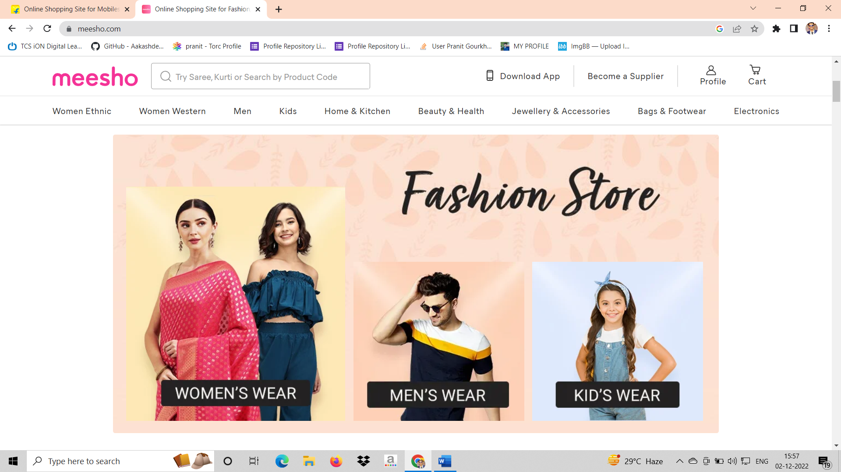

1. PRODUCT PAGE FOR YOU & FILTERS

SELECT YOUR PRODUCT AND EARN BENIFITS

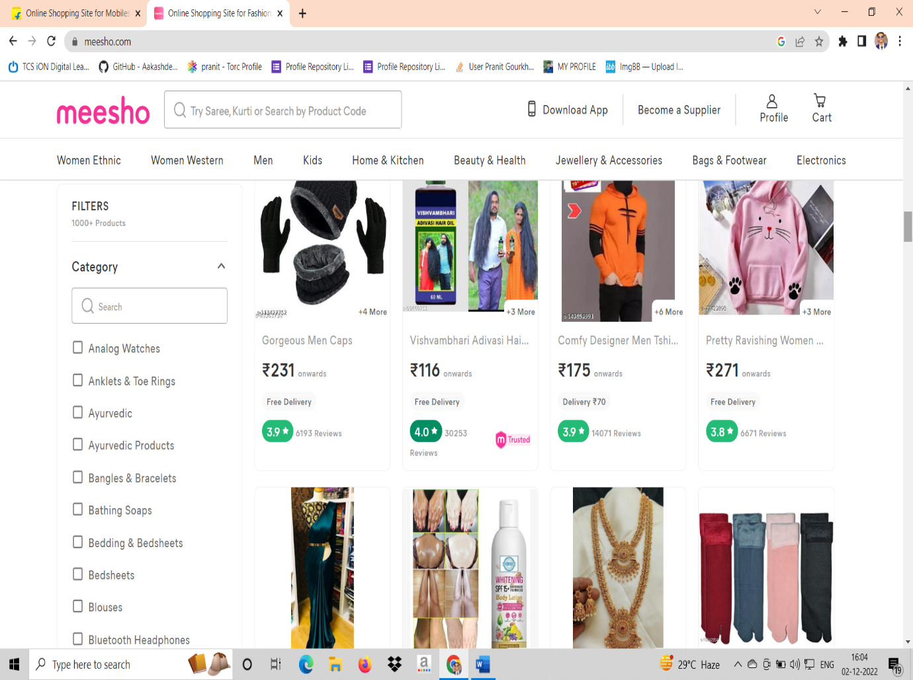

PAYMENT METHODS

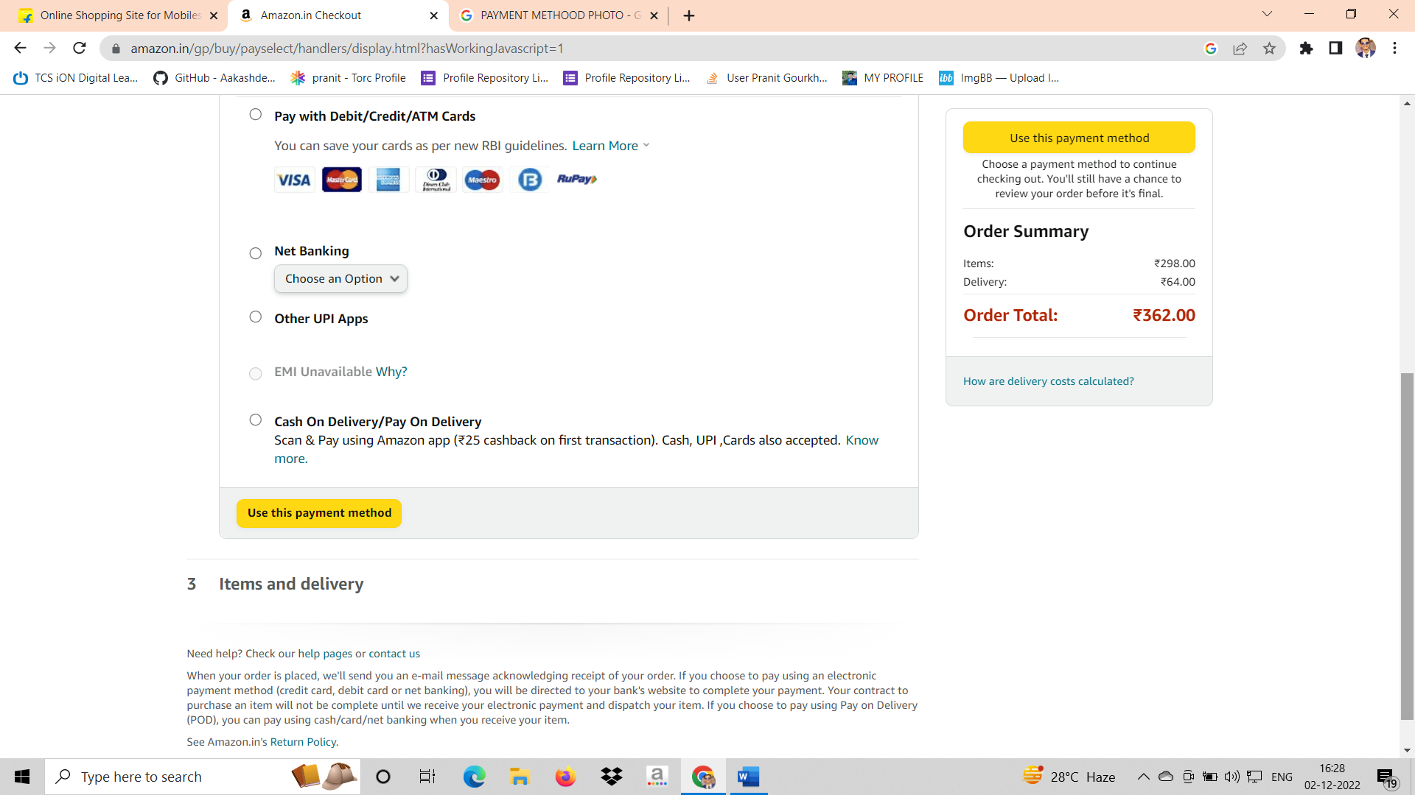

FOOTER

1. About
   1. Contact us
   2. About us
   3. Career
2. Help

2.1) Payment

2.2) Shipping

2.3) Cancellation and return

OUR PARTNER’S